US restaurant launches 'Modi ji thali’ ahead of PM's visit. Watch

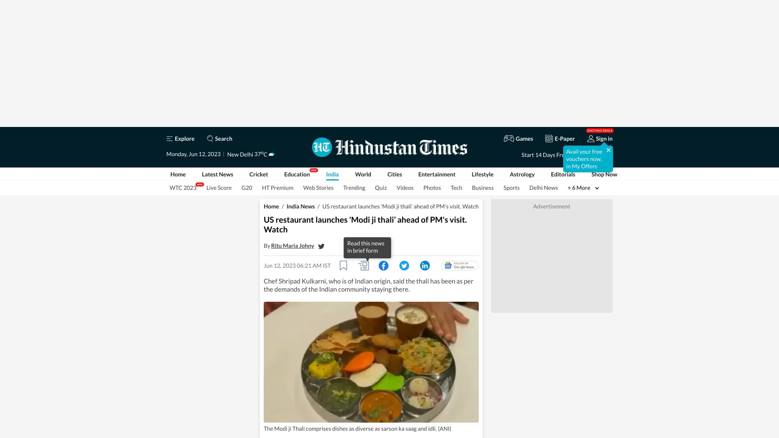

https://www.hindustantimes.com/india-news/pm-modi-us-visit-modi-ji-thali-new-jersey-restaurant-year-of-millet-101686530395089.html

In honor of Prime Minister Narendra Modi's upcoming visit to the US, a restaurant in New Jersey has created a 'Modi ji Thali' consisting of Khichdi, rasgulla, sarson ka saag, Kashmiri dum aloo, idli, dhokla, chaach, and papad. A second thali dedicated to External Affairs Minister S Jaishankar is also being planned in honor of the International Year of Millets. Similar thalis were launched in Delhi last year in celebration of PM Modi's birthday.

0.0

US Restaurant Creates ‘Modi Ji Thali’ In Honour Of PM Narendra Modi’s US Visit Later This Month

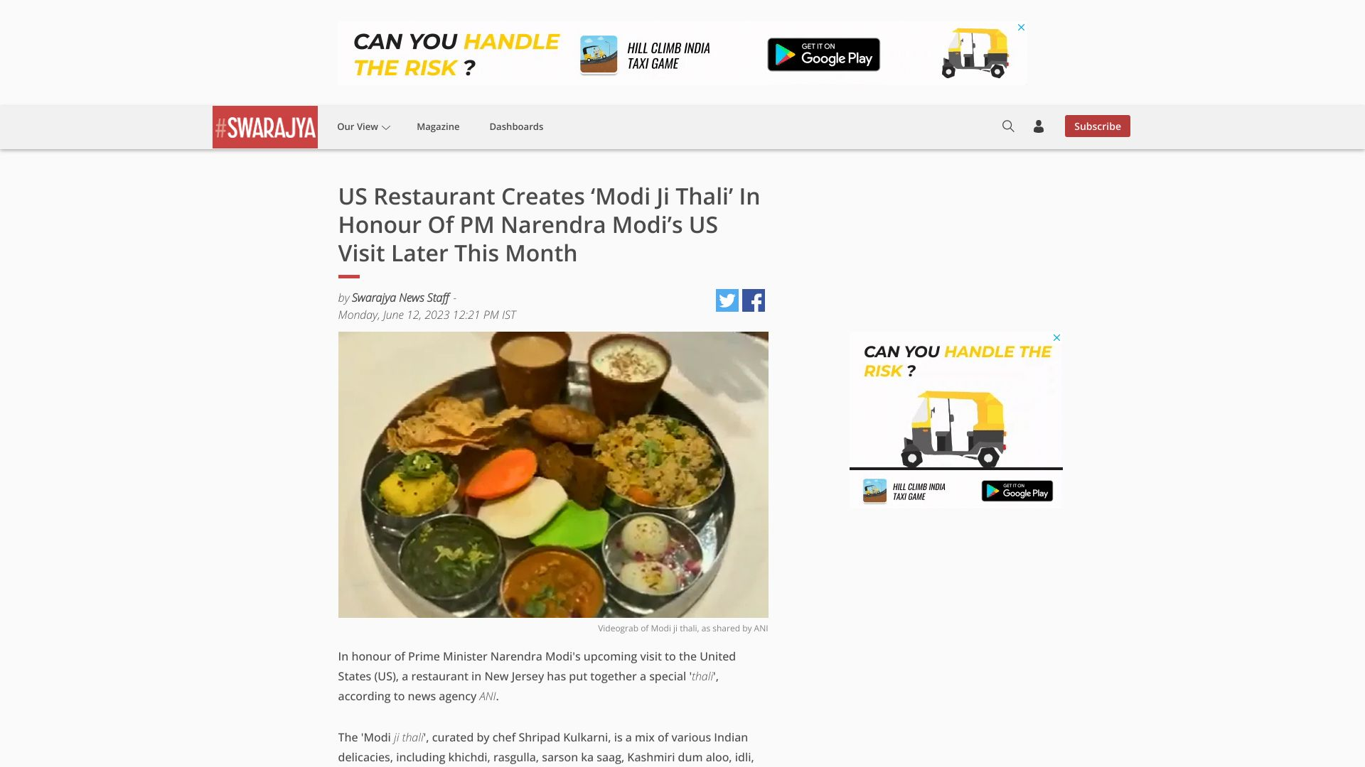

https://swarajyamag.com/insta/us-restaurant-creates-modi-ji-thali-in-honour-of-pm-narendra-modis-us-visit-later-this-month

An Indian restaurant in the USA is launching Thali dedicated to Indian External Affairs Minister Dr S Jaishankar and celebrating International Year of Millets. Meanwhile, Indian-American community is organizing 'India Unity Day' marches and a yoga celebration to welcome Prime Minister Narendra Modi on his second state visit to the USA. He is set to address the joint meeting of the US Congress and will be welcomed by the US President and First Lady for a dinner.

0.0

Development core issue for Global South: PM Modi at G20 meet

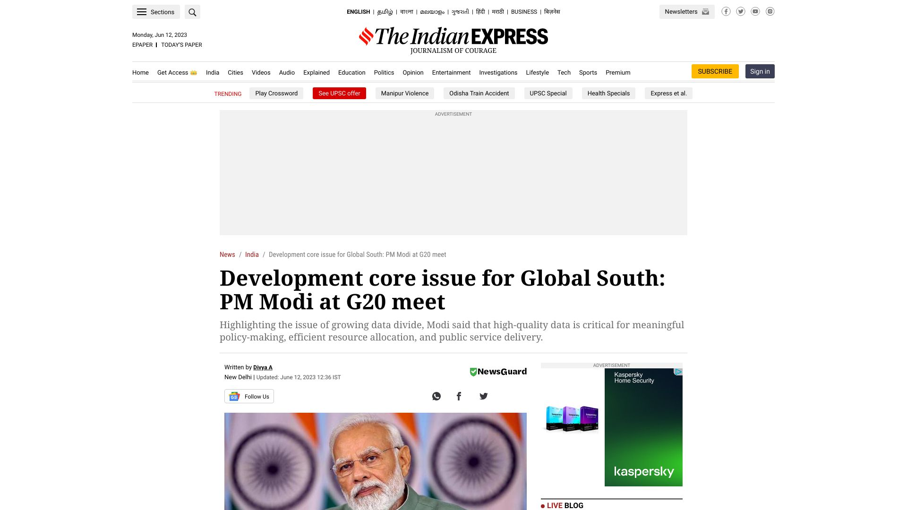

https://indianexpress.com/article/india/pm-narendra-modi-g20-development-ministers-meeting-8658089/

At the G20 Development Ministers' meeting in Varanasi, Prime Minister Narendra Modi urged reform of multilateral financial institutions to make finance more accessible to the Global South amid the Covid pandemic and geo-political tensions. He also proposed India's Aspirational Districts programme as a means of furthering Agenda 2030.

0.0

Indian PM Modi's state visit to the US | Promo

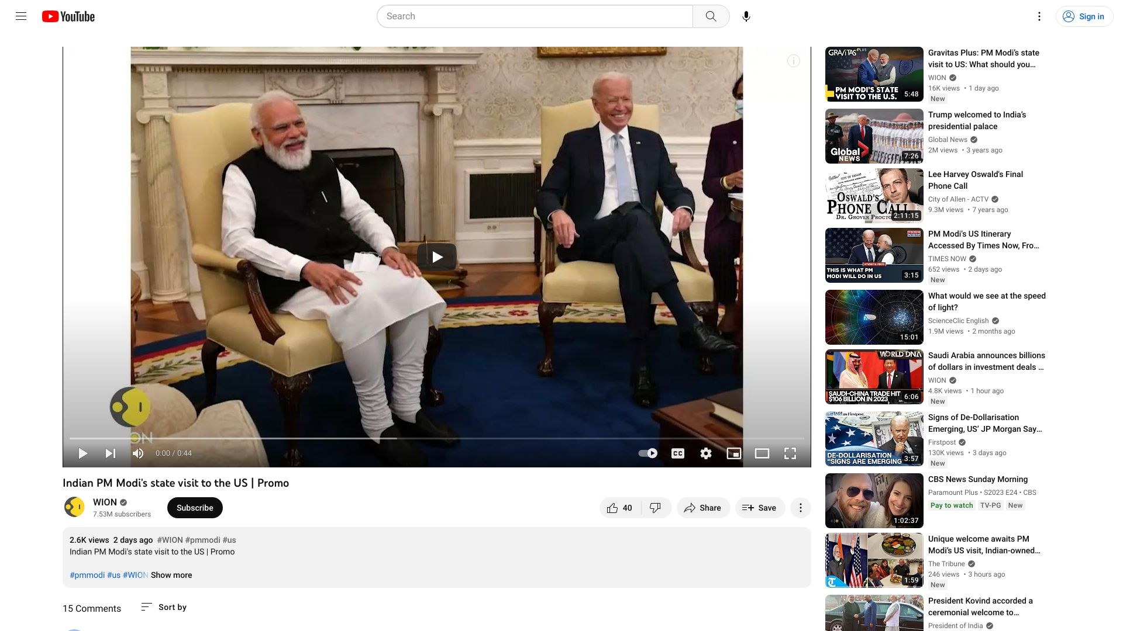

https://www.youtube.com/watch?v=E4d9EBpWuRs

Indian Prime Minister Narendra Modi is set to make his first State visit to the United States, where he will be honored with a 21-gun salute, a grand State dinner, and an address to the Joint session of Congress. India and the U.S. are working to strengthen their partnership, and Our World is One will be following the developments of the visit.

0.4

PM Modi attends Mega community programme in Sydney, Australia

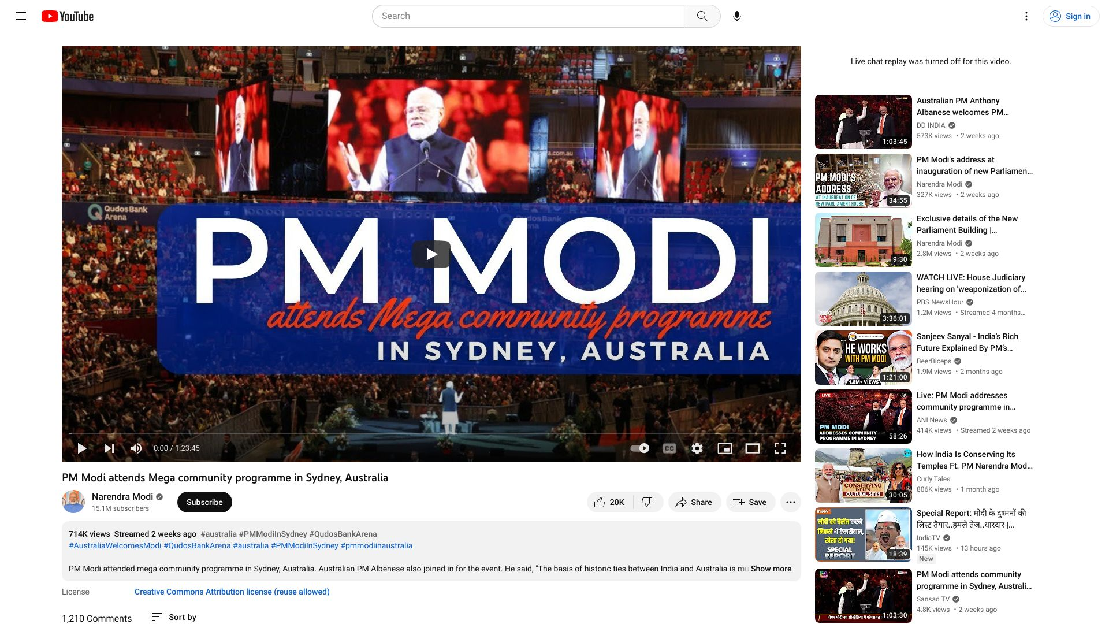

https://www.youtube.com/watch?v=BBRAIm4jxsM

"PM Modi attended a mega community programme in Sydney, Australia and was welcomed by the people of Australia.",

0.8

PM Modi dedicates new Parliament House to the nation

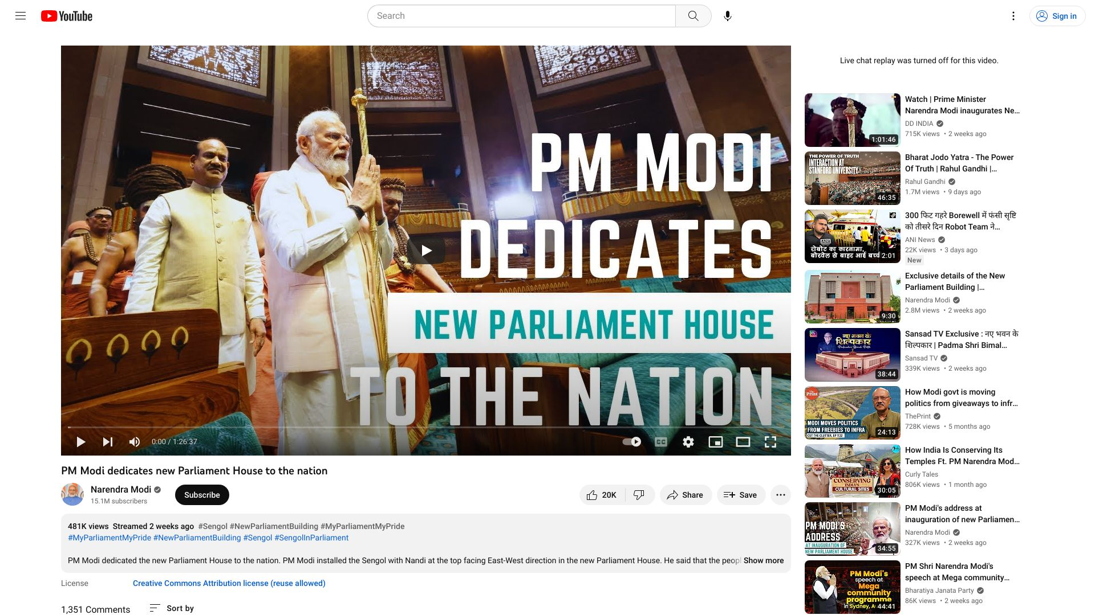

https://www.youtube.com/watch?v=C43UVrXIqPw

"PM Modi dedicated the new Parliament House to the nation",

0.8

PM Modi's remarks at the 3rd FIPIC Summit in Papua New Guinea- With Subtitles

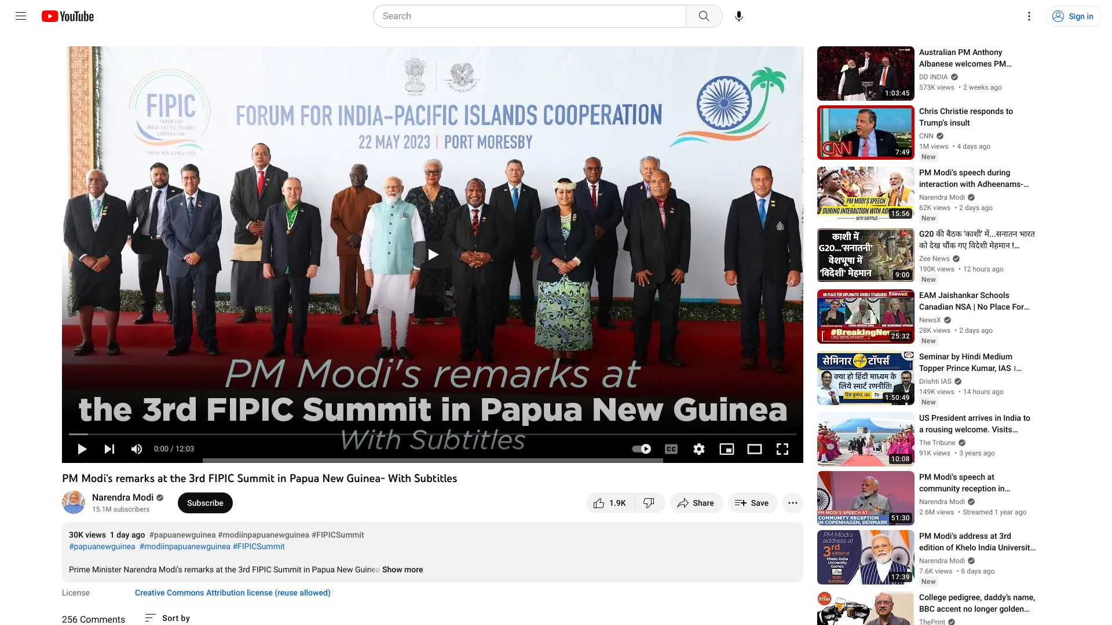

https://www.youtube.com/watch?v=DcCawCVt_jg

"Prime Minister Narendra Modi's remarks at the 3rd FIPIC Summit in Papua New Guinea focused on the importance of strengthening ties between India and the Pacific Island countries, and the need to work together to tackle global challenges.",

0.8

PM Modi की वापसी संभव नहीं | RSS | Rahul Gandhi | America Visit | India News | Congress | #dblive

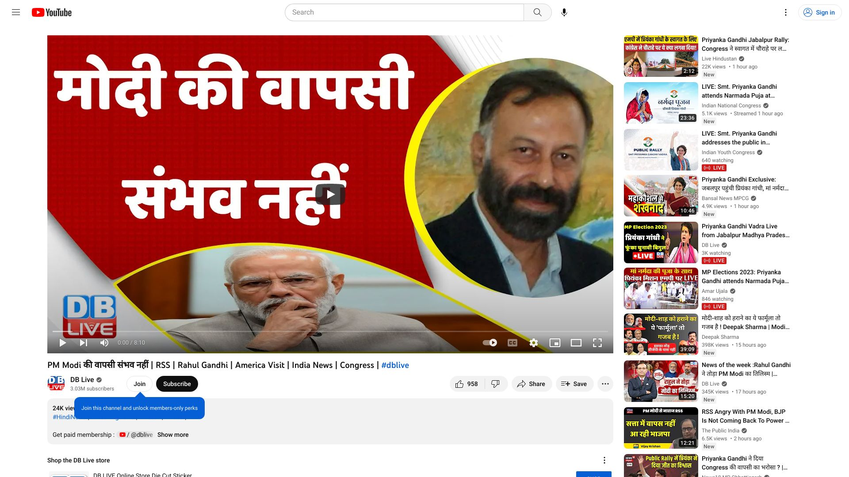

https://www.youtube.com/watch?v=pmHhmtsa2yk

"PM Modi's return is not possible, RSS, Rahul Gandhi, America Visit, India News, Congress",

0